.
EIGHTEENMILE CREEK PHASE II RESTORATION

Project Purpose

- Continue restoration of the physical, biological, and chemical integrity of the Eighteenmile
Creek ecosystem

Project Goal and Objectives

- Improve habitat for coldwater fish species downstream of the Burt Dam
- Additional access to the popular fishing area along Eighteenmile Creek
- Enhancement of streamside wetlands
- Improve water quality of Eighteenmile Creek, and eventually Lake Ontario
- Introduce various species to the existing riparian plant community

Project Features

- Low flow deflector/access wall
- Bankside fishing access points
- Hydraulic coverstones
- Bendway weirs
- Wetland perimeter armoring

Project Summary

Niagara County Soil & Water Conservation District has secured funds to initiate Phase II of the restoration of Eighteenmile Creek below Burt Dam. The project consists of the placement of large-rip rap stones along the east and west banks to re-define and narrow the channel to its former configuration, and to create a wetland area along the east shoreline. The project also plans to place additional hydraulic cover stones in the creek as well as restore wetland vegetation.

Approximately 560 lineal feet (375 tons) of large-rip-rap stone will be placed along the east bank of Eighteenmile Creek to narrow the channel to its former configuration and to create a low flow deflector/fishing access wall. Three hundred and forty (340) lineal feet (63 tons) of hydraulic cover stones will be placed along the west bank of Eighteenmile Creek to better define the channels shape and protect the wetland marsh present along said bank. Fifty (50) hydraulic covers stones (88 tons) will also be placed in Eighteenmile Creek north and south of the railroad trestle. Approximately 44,000 cubic feet (1650 yd³) of clean organic fill suitable for wetland species will be placed into the proposed wetland restoration area.

The purpose of the project is to continue the restoration of the physical, biological, and chemical integrity of the Eighteenmile Creek ecosystem and improve existing access to the popular fishing area along Eighteenmile Creek. The project addresses several priorities of the Great Lakes Restoration Program including:

- Restoration, protection, and enhancement of stream corridors for protecting and improving water quality, protecting and enhancing fish and wildlife habitats, eliminating or minimizing streambank erosion and reducing sediment loads to streams and lakes;
- Protection and restoration of watershed functions for maintaining base flow and water quality necessary to sustain fish and wildlife within streams, and associated wetlands; and
- Restoration, protection, and enhancement of riparian habitats, including in-stream and freshwater habitats.

The stabilization of the creek banks is necessary to prevent future erosion and to maintain safe access to the creek for fishing below Burt Dam. The creation of the wetland area will re-establish the viable marsh habitat that once existed in this location. The overall project will involve using both "hard" (i.e., rock riprap wall) and "soft" (i.e., vegetative plantings) methods. Due to the extensive use of the area by anglers and water level fluctuations, bioengineering alone will not provide a sound long-term solution to prevent future bank erosion and wetland degradation. Only the minimum materials necessary for erosion protection, bank definition and habitat creation will be used to complete the project.

1.0 Pre-Construction

Once all of the necessary permits have been secured, project partners will begin to acquire the materials required to complete the project. As materials are purchased they will be stockpiled on the bluff within the parking area of Fisherman's Park. This area is well away and above the creek and has been used for years as a parking lot for access to the creek. There will be no filling of jurisdictional wetlands or waters of the State/U.S. as a consequence of the stockpiling activities.

Best Management Practices (BMPs) will be established and implemented before construction activities begin, since most of the work will occur in and/or within 100 feet of a NYSDEC wetland. These BMPs are listed in Section 3. Before in-water work begins, a turbidity curtain will be placed in a perimeter outside the work area to limit the movement of suspended sediments.

2.0 Construction Sequence

I. Low Flow Deflector/Fishing Access Wall

Construction work will begin at the farthest upstream end of the low flow deflector/fishing access wall, progressing downstream until the wall meets the main access point below the parking lot. Initially, the wall will be keyed twenty feet into the existing bank and access trail. The wall will then be constructed in twenty foot sections. The first twenty foot section will be constructed from on-shore. Once completed, the first twenty foot section will be lined with an impermeable material and sand bagged on the upstream side to divert flow from the work area. Utilizing the protection of the first twenty foot section, equipment will then enter the creek and construct the next twenty foot section. This section will then be lined and sand bagged as previously described. Construction of the wall will continue in this manner until the downstream end is keyed twenty feet into the existing bank and access trail.

The turbidity curtain encompassing the perimeter of the work area will then be removed.

II. Logistical Rock Placement

A. Upstream of Rail Trestle

After the area work area has been fully de-watered, the hydraulic covers stones planned along the west bank and within the creek will be placed along the downstream side (de-watered) of the rock wall. Once all of the coverstones are behind the rock wall, they will then be lifted over the wall and placed into clusters in the creek at ten strategic locations upstream of the rail trestle. Placing the coverstones clusters in strategic locations will minimize the time necessary to have construction equipment in the water. This will also minimize the in-stream movement of construction equipment and drastically reduce the potential to re-suspend sediments.

B. Downstream of Rail Trestle

All hydraulic coverstones downstream of the rail trestle are planned to be placed within the stream. Once all of the coverstones have been stockpiled behind the rock wall, they will be lifted over the wall and placed in the creek.

III. Define and Armor West Bank

Defining and armoring the west bank will require in-stream work. With the hydraulic coverstones clusters already strategically placed in the creek, construction equipment will then enter the creek and begin placing rock along the west bank. Once the first coverstone is placed along the west bank, the turbidity curtain will be secured and stretched along the west bank until it intersects the upstream end of the rail trestle. Placement of the coverstones along the west bank behind the turbidity curtain will proceed in a downstream direction until completed.

IV. Place In-stream Hydraulic Cover Stones

A. Upstream of Rail Trestle

Once all of the stones have been placed along the west bank, each of the ten strategically placed rock clusters will have approximately 2 stones remaining for in-stream placement. As the equipment makes it way back upstream, the stones from each cluster will be moved into final position.

B. Downstream of Rail Trestle

The hydraulic coverstones planned for placement within the creek downstream of the rail trestle were all placed in step II of the construction sequence.

V. Wetland Soil Placement

Once all rock is in place and assuming the work area is still de-watered, approximately 44,000 cubic feet (1650 cubic yards) of clean organic fill suitable for wetland species will be placed into the proposed wetland restoration area. The surface area of fill for the wetland work within a waterbody (i.e. channel of Eighteenmile Creek) will be approximately 29,000 square feet. This estimate assumes the maximum depth of fill into the channel throughout the work area (i.e. 2 feet), and are conservatively high. Depending upon conditions in the field, only the minimum amount of material needed for wetland creation will be used, as necessary.

VI. Vegetate Wetland Area and Disturbed Areas

The entire area of restored wetland will then be planted with various obligate and facultative wetland species to assist in keeping the fill in place as well as establish additional habitat benefits. The focus of the vegetation plan is to select plant species with superior wetland diversity and habitat enhancement properties and to help to steer angler access along portions of the streambank. Species selections are also based on the abilities of the plants to become established within existing plant communities in this region. Species selection was conducted, in part, by referencing the United States Fish and Wildlife Service (USFWS) wetland indicator classification for plant species occurring in this region.

All areas disturbed by construction activities will be reseeded to prevent any future erosion.

SPECIALIZED WETLAND MIX FOR SHADED OBL-FACW MIX: ERNMX-137
25% Carex vulpinoidea Fox Sedge
25% Elymus virginicus Virginia Wild Rye
8% Sparganium americanum Eastern Bur Reed
7% Juncus effusus Soft Rush
6.5% Onoclea sensibilis Sensitive Fern
5% Aster umbellatus Flat Topped/Umbrella Aster
5% Scirpus polyphyllus Many Leaved Bulrush
5% Carex comosa Cosmos Sedge
5% Carex lurida Lurid Sedge
3% Sagittaria latifolia Duck Potato/Arrowhead
2% Carex lupulina Hop Sedge
1% Carex crinita Fringed Sedge
1% Dulichium arundinaceum Three Way Sedge
0.5% Cinna arundinacea Wood Reedgrass
0.5% Juncus canadensis Canada Rush
0.5% Caltha palustris Marsh Marigold

VII. Project Area Clean-up and Place Signage

Once all construction activities have ceased and all fill is in place, the work area will be cleaned and left in the same condition that existed pre-construction.

A sign will be erected at both ends of the rock wall barrier designating this area as additional fishing access. Two sign will also erected along the east bank, in approximate alignment with the beginning of the restored wetland area. The sign will inform users of the creek to utilize the rock wall and not disturb or walk through the wetland habitat area.

3. Erosion and Sediment Control

Best Management Practices (BMPs) will be installed within the project area to limit negative impacts to the floodway/wetlands and stream/riparian zones (i.e. minimization of sedimentation and siltation of instream substrates). For example, timing of in-water work will be limited to the duration necessary for project completion, and is tentatively scheduled for late summer when stream flows within the creek are within the annual low flow cycle. In addition, no fish migrations will be occurring at this time.

Additional BMPs related to erosion and sediment control include:

- preserving existing vegetation to maximum extent possible;
Several trees will need to be removed on the northern and southern ends of the wetland area. Efforts will be made to preserve large trees that are currently providing suitable bank stability.

- phasing construction to limit exposed soils;
Construction will begin at the northern end of the project area to provide equipment access to the southern end of the project area. As the work progresses, disturbed areas where work is complete, will be reseeded and mulched to limit the time disturbed soils are exposed.

- protecting steep slopes and cuts;
Silt fences will be placed below any steep slopes or cuts during non-work times, until stabilization work is complete.

- employing perimeter controls; and
Silt fences or erosion control fabric will be used in or around work areas to prevent the transport of eroded sediment. This will allow for the capture and retention of any disturbed sediments.

- ensuring that BMPs are being properly installed, maintained, and inspected.
Erosion and sediment controls will be inspected at the beginning of each workday. Necessary maintenance will occur, prior to the initiation of construction activities.

BMPs used to limit the disturbance and input of fines during in-water work will include:

- the placement of a turbidity curtains and/or impervious materials around disturbance areas to isolate or confine the turbid areas:
The in-water work areas will be isolated to prohibit the resuspended sediments from increasing turbidity of the creek and wetlands downstream from the project area. All barriers will be in place prior to initiation of all work.

- limiting time vehicles are in water; and
Construction activities will begin at the southern end of the site. In-water work activities will be conducted on the same day or consecutive days to limit in-water work time.

- using only rubber tracked tires for in-water work.

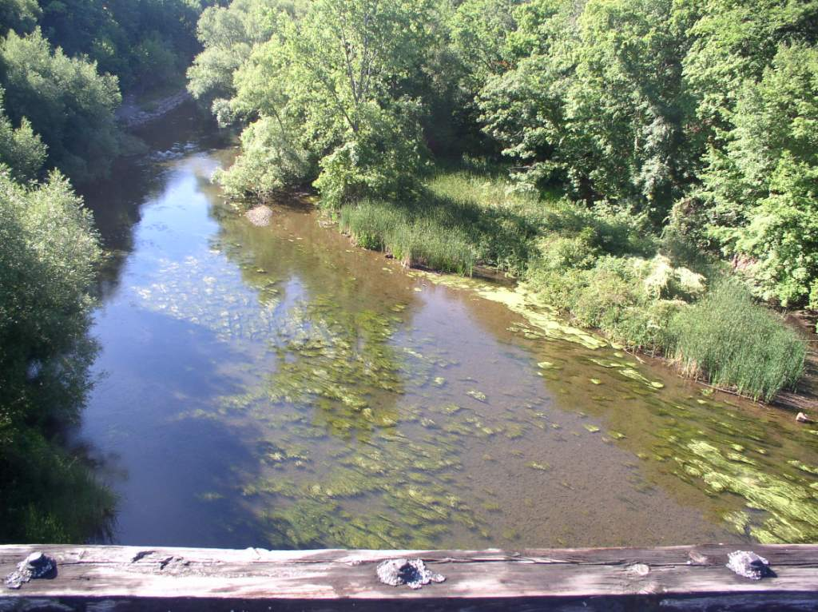
BEFORE

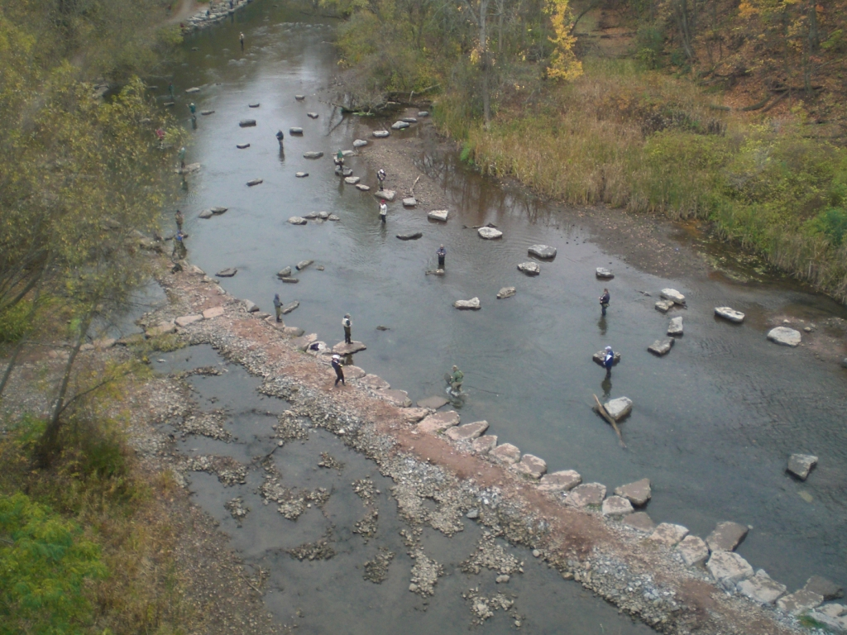
AFTER
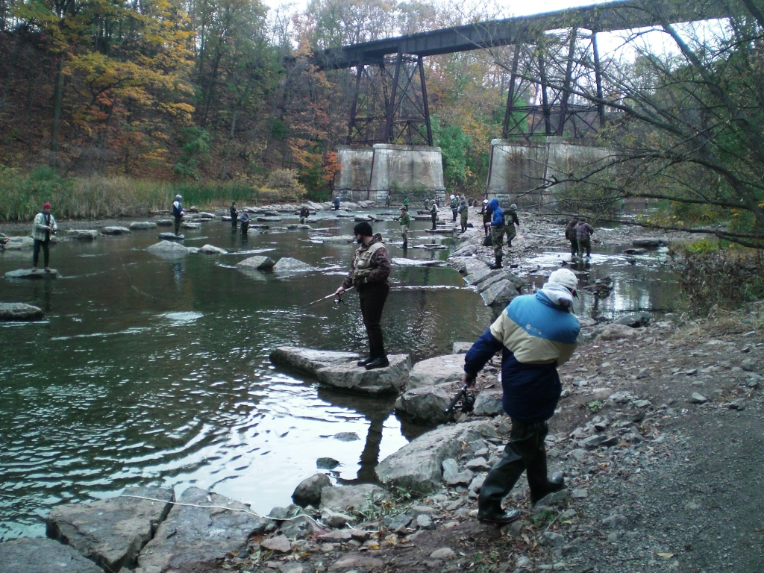
AFTER
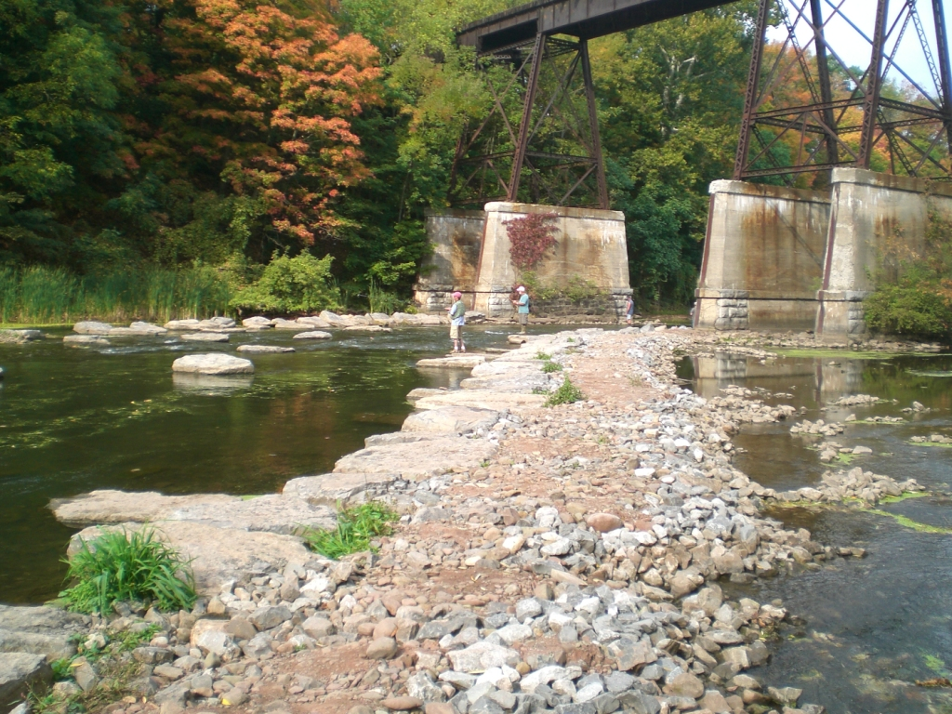\
AFTER

